1. download Python: <https://www.python.org/downloads/>

1. Install python and make sure to add path before installing

1. Once installed open CMD(command prompt) and run python --version as well as pip --version to make sure you are on latest versions
2. 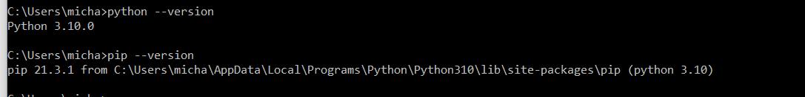on command prompt run pip install robotframe work then

pip install robotframework-seleniumlibrary

1. Setting up chrome driver <https://chromedriver.chromium.org> make sure to download the same version your google chrome has.

You can check which version is need by opening google chrome go to setting (top right 3 vertical lines ) go to help and about google then you will see your version

1. Graphical user interface, text, application

   Description automatically generatedGraphical user interface, application

   Description automatically generatedFor windows (If you are using Mac go to step 7)extract the chrome driver file into location python was saved usually saved in user/user_name/appdata/local/programs/python/python_version
2. Graphical user interface, application

   Description automatically generated For mac only the chrome driver does not need to be extracted just drop into location python was downloaded
3. Now framework and Selenium should be installed and working recommended to use WebStorm for project